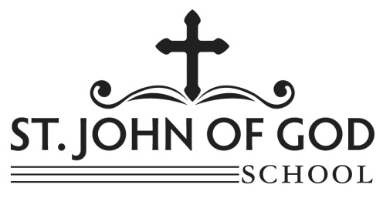**Grades 5- 7 Supply List**

**2020-2021**

The following supplies will be needed to start the school year. Teachers will notify parents and students if more supplies are needed during the year. Supplies marked with a star (*) are suggested supplies to have a second set at home.

Reminder: Students will not be able to share any supplies with others. Each student will need their own supplies.

|  |  |  |
| --- | --- | --- |
| 4 |  | Sharpened, #2 Pencils with Erasers * |
| 4 |  | Black Ballpoint Pens * |
| 4 |  | Red Ballpoint Pens * |
| 1 |  | Pencil Bag/ Box |
| 1 |  | 12 Inch Ruler with Centimeters * |
| 3 |  | Composition Notebooks: 1 for ROBOTICS/INQUIRE 1 for WRITING WARM-UP 1 for RELIGION |
| 2 |  | Boxes of Kleenex (family size tissue) |
| 2  2 |  | Containers of Disinfectant Wipes  Bottle of Hand Sanitizer |
| 1 |  | Texas Instrument T1-30XA Scientific Calculator |
| 1 |  | Geometry Template and Protractor |
| 1 |  | Safety Compass (to be purchased from the school office in September) |
|  |  | **Students will need their own pack of Dry erase markers/ eraser \*** |
| 1  2 |  | **Students will need a mini Dry Erase board to have at home \***  Pack of College Ruled lined notebook paper for home *  Reams of White Copy Paper |
| 3  1 |  | Single Subject, College Ruled “5 Star Notebook”, **9” x 11” (Social Studies, MATH, SCIENCE)** Three Subject, College Ruled 5 Star Notebook 9 x 11—ELA (Literature, Writing, Grammar) |
| 1 |  | Backpack |
| 1 |  | Computer Headphones |
| 1 |  | Robotics Kit –See Attached Flyer |
| 1 |  | **Art Supply List**:  Art Box (to hold all supplies) |
| 1 |  | Large Set of Colored Pencils (at least 24 pencils) |
| 1 |  | Pink Pearl Eraser |
| 1 |  | Large Set of Crayons (approx. 24 crayons) * |
| 1 |  | Set of Markers (bright, basic colors) * |
| 2 |  | Glue Sticks to start the year (more will be needed throughout the year) * |
| 1  1 |  | Pair of Scissors*  Sketch Notebook/Diary |
|  |  |  |

**Students are required to label all supplies with their name and subject.**

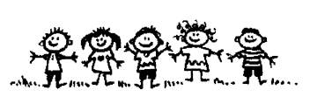

MISSION STATEMENT

At St. John of God Catholic School, we foster a faith-filled Christian community

in which we develop the whole person: body, mind and spirit.